Final project STATS

Effect of legume residue in cooperation on soil quality in two contrasting smallholder communities in Kenya-A comparison of a Soil Tool Kit with mid-Infra-red spectroscopy

Understanding soil quality variability following legume residue in cooperation in maize-legume systems-A case of contrasting smallholder communities in Kenya.

1. What are the soil properties influencing variability in soil quality after additions of legume residues?

PCA on just mirs

PCA on just envrionmenta

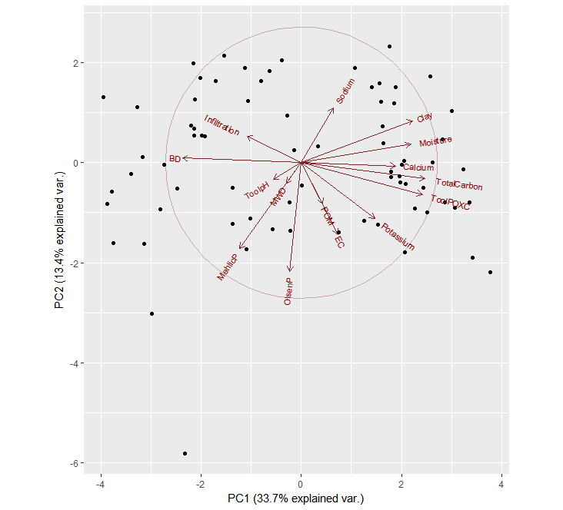

Not on both coz collinearity might lead to loss of info if combined

1. What is the relationship between MIRS reflectance and N, P, C organic fractions among fields following legume integration.

See homework on how to report

Permutation test (ANOVA on the constrained axis)

RDA

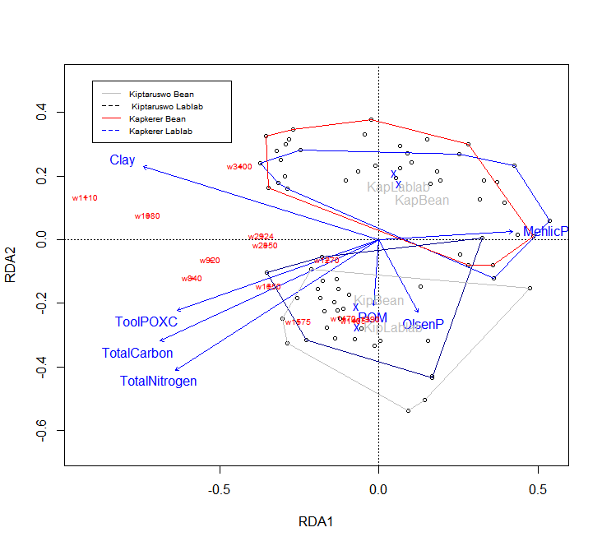

3) What are the soil properties (functional groups included) bands that can allow for short term detection of change in soil quality following legume integration in two communities. (

Is there any difference in the treatments on soil quality and band widths?

MANOVA/permanova

Random forests

Do typologies exist??

Cluster analysis???